Installation Guide

Install docker desktop



Open docker desktop

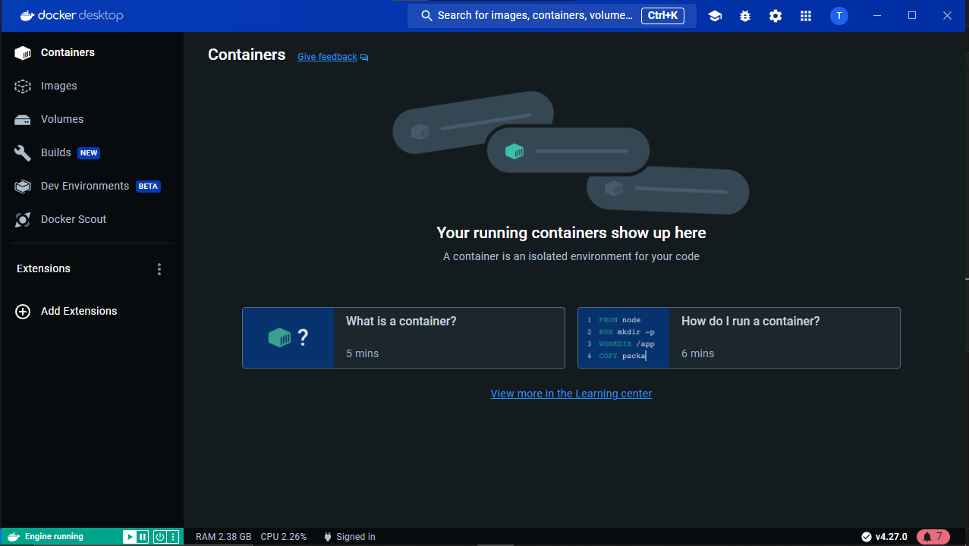

Create new folder

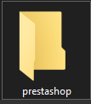

Open folder with vscode

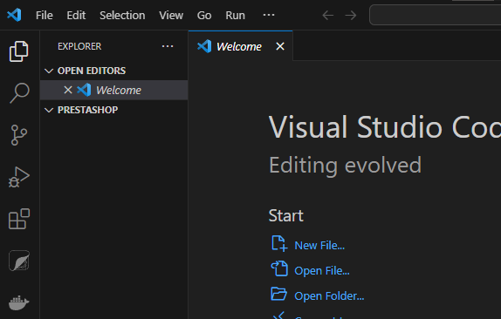

Create new file and named it docker-compose.yml

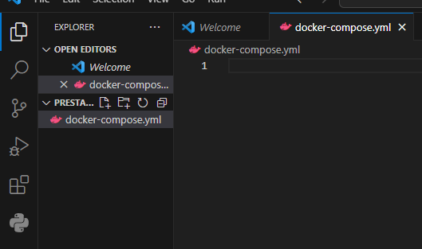

In docker-compose.yml use this code

version: '3'

services:

phpmyadmin:

image: phpmyadmin/phpmyadmin

container_name: phpmyadmin

links:

- mysql

environment:

PMA_HOST: mysql

PMA_PORT: 3306

PMA_ARBITRARY: 1

restart: unless-stopped

ports:

- "8081:80"

networks:

- prestashop_network

mysql:

container_name: some-mysql

image: mysql:5.7

restart: unless-stopped

environment:

MYSQL_ROOT_PASSWORD: admin

MYSQL_DATABASE: prestashop

networks:

- prestashop_network

volumes:

- dbdata:/var/lib/mysql

prestashop:

container_name: prestashop

image: prestashop/prestashop:latest

restart: unless-stopped

depends_on:

- mysql

ports:

- "8080:80"

environment:

DB_SERVER: some-mysql

DB_NAME: prestashop

DB_USER: root

DB_PASSWD: admin

PS_FOLDER_ADMIN: admin_prestashop

PS_FOLDER_INSTALL: install_prestashop

networks:

- prestashop_network

volumes:

- psdata:/var/www/html

networks:

prestashop_network:

volumes:

psdata:

dbdata:

Save docker-compose.yml

Open terminal on vscode

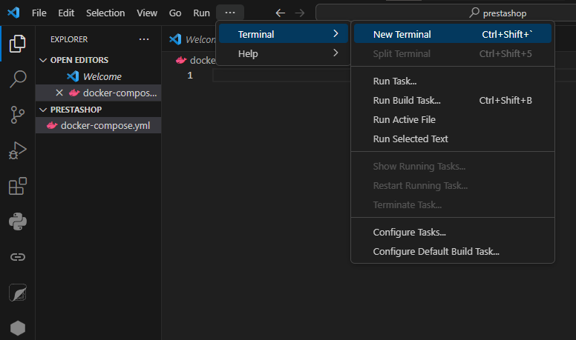

If you not use vscode you can use Command line and switch directory to the folder that you save docker-compose.yml

Use command docker compose up -d

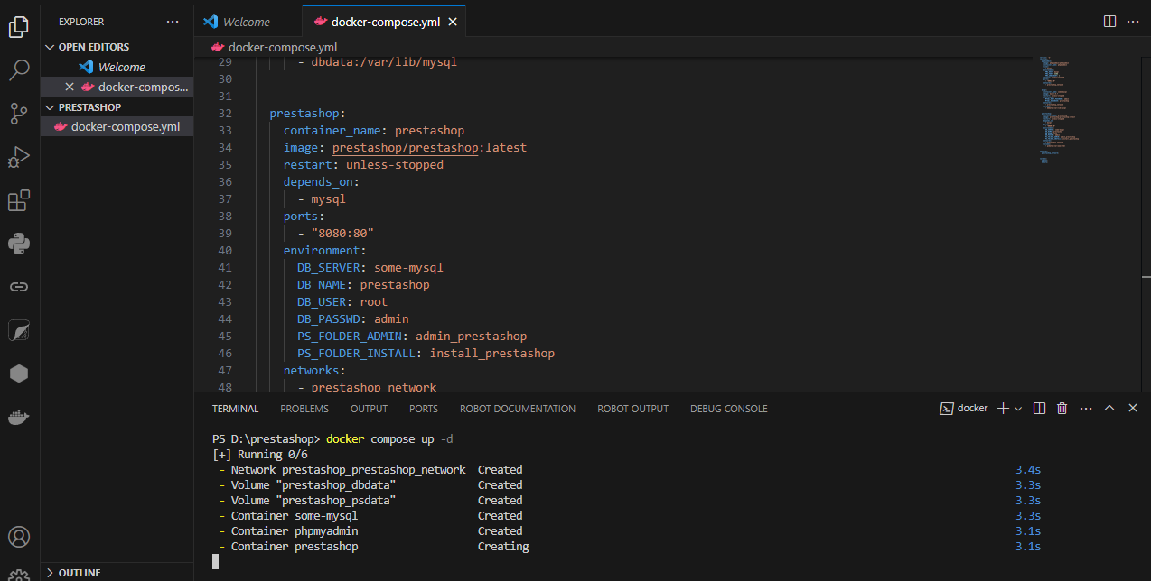

Now it will pull container from repository and it will create network and volume

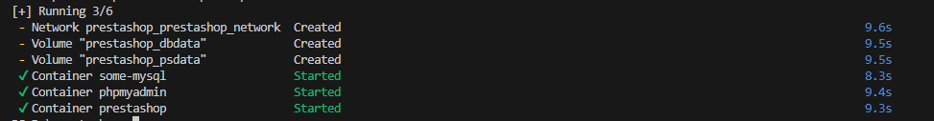

After it finished open web browser and in url use <http://localhost:8080/install_prestashop>

It will open install page

Click Next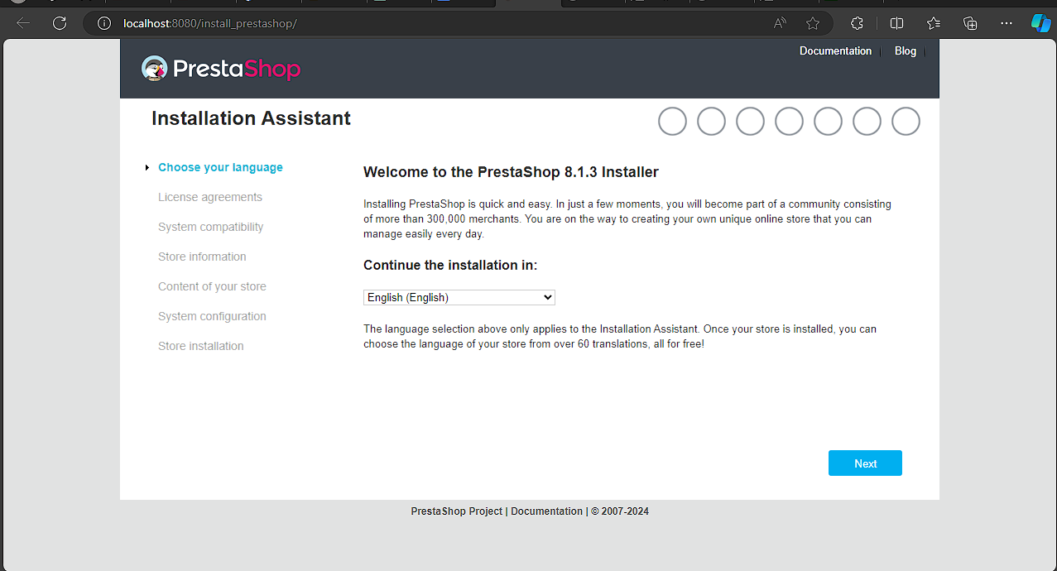

Click check and then Next

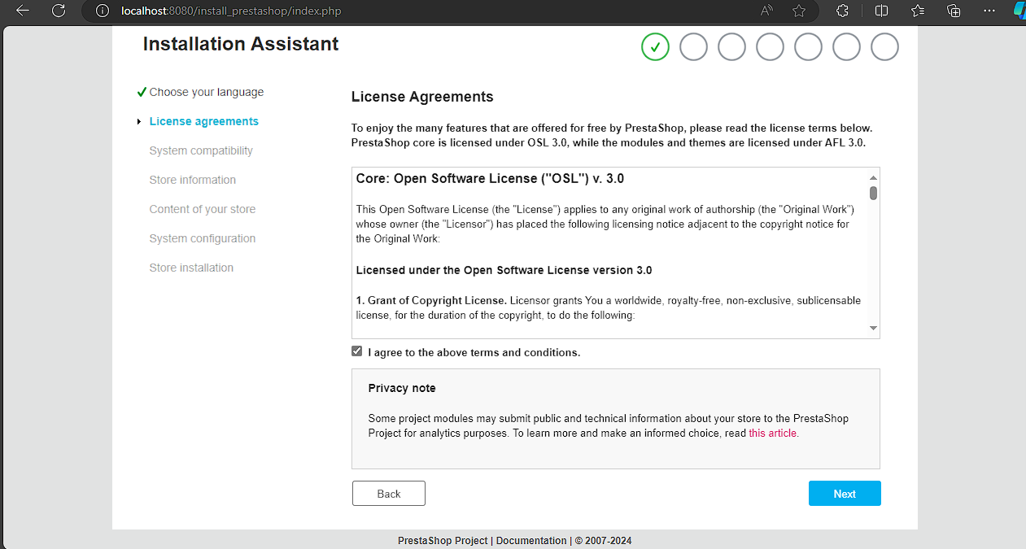

Fill form you need to remember the email and password for admin page

And click Next

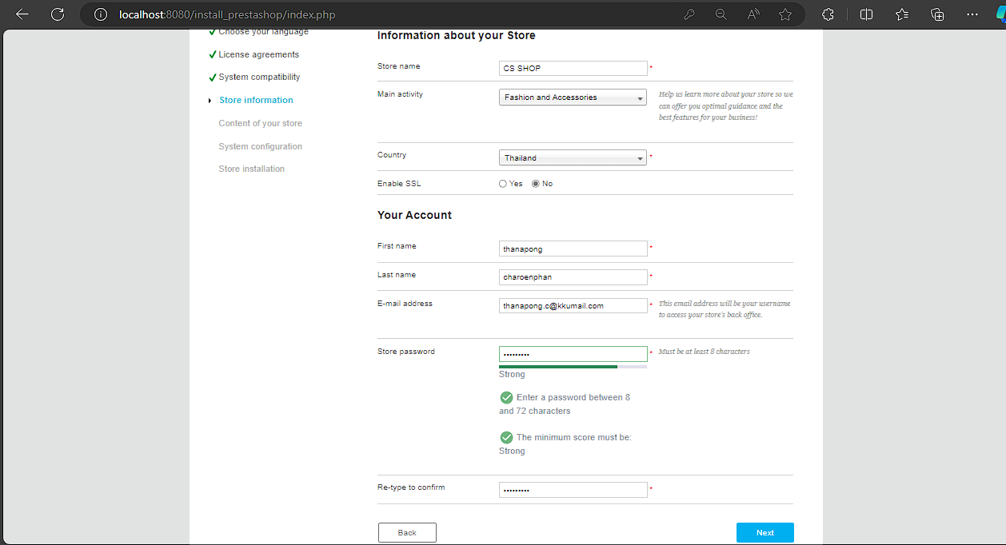

Click Next

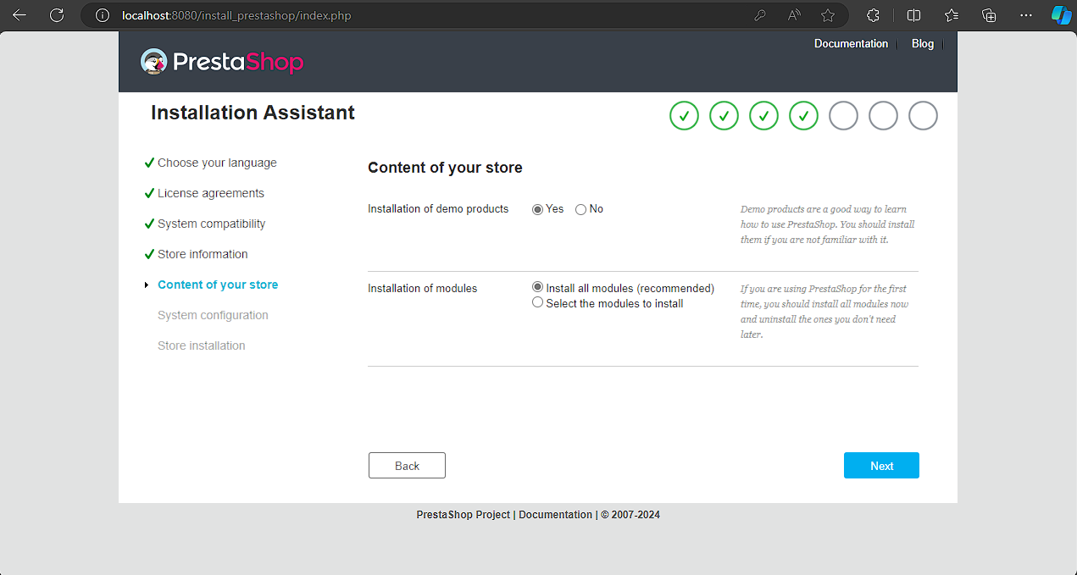

In Database server : some-mysql

Database name : prestashop

Database login : root

Database password : admin

environment:

DB_SERVER: some-mysql

DB_NAME: prestashop

DB_USER: root

DB_PASSWD: admin

This is from your code in docker-compose.yml

Then test your database connection

If database is connected click next

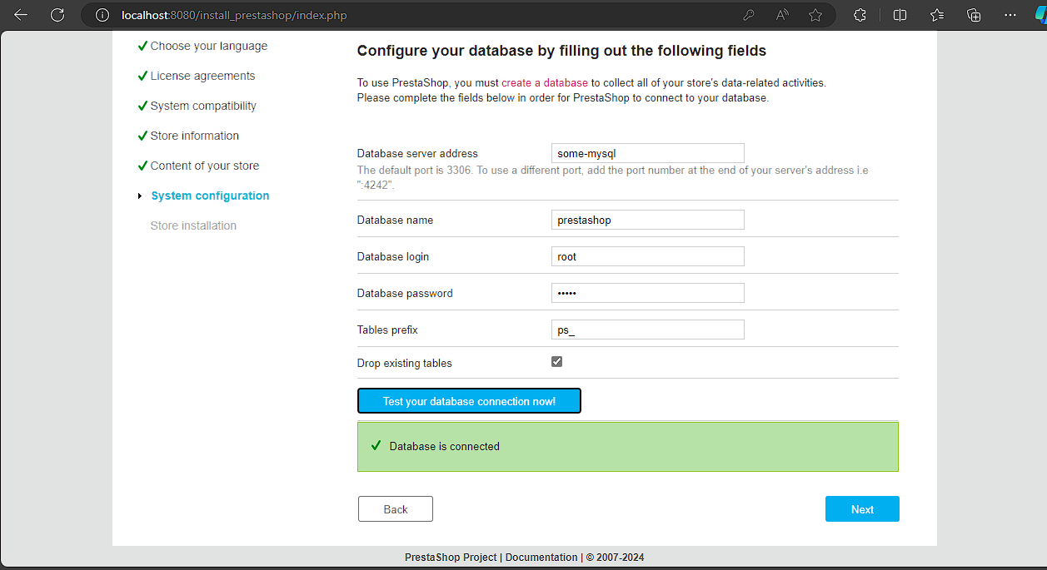

It will appeared download bar wait for it

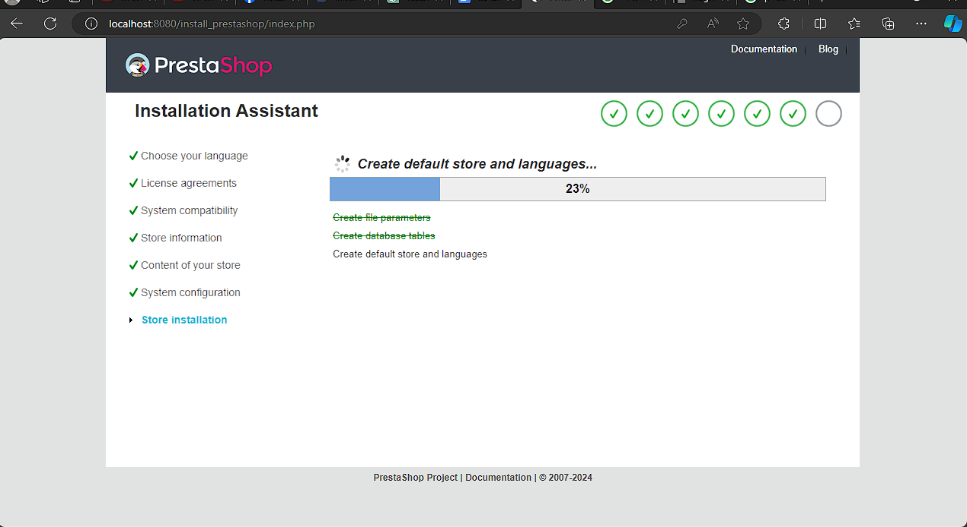Now prestashop is ready to use

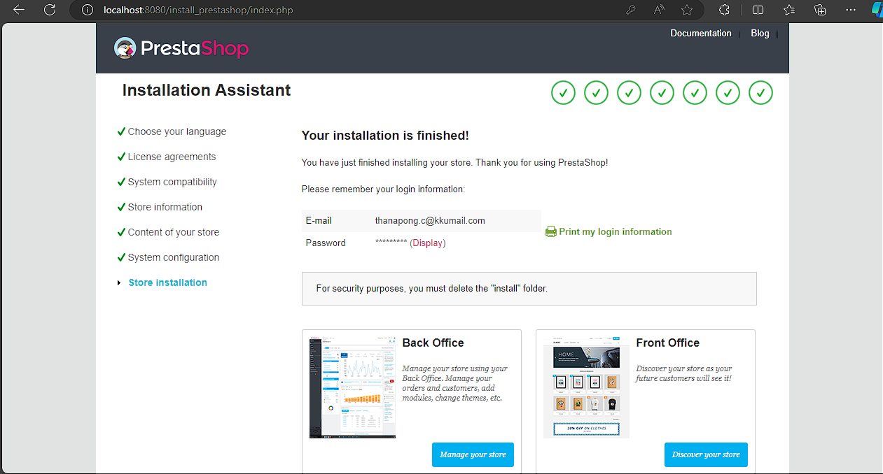

Back Office is for admin

You need to change url to [http://localhost:8080/admin_prestashop](http://localhost:8080/install_prestashop)

Front Office is show your store